UX Check Results

# Heuristic: Consistency and standards

# Severity: 4

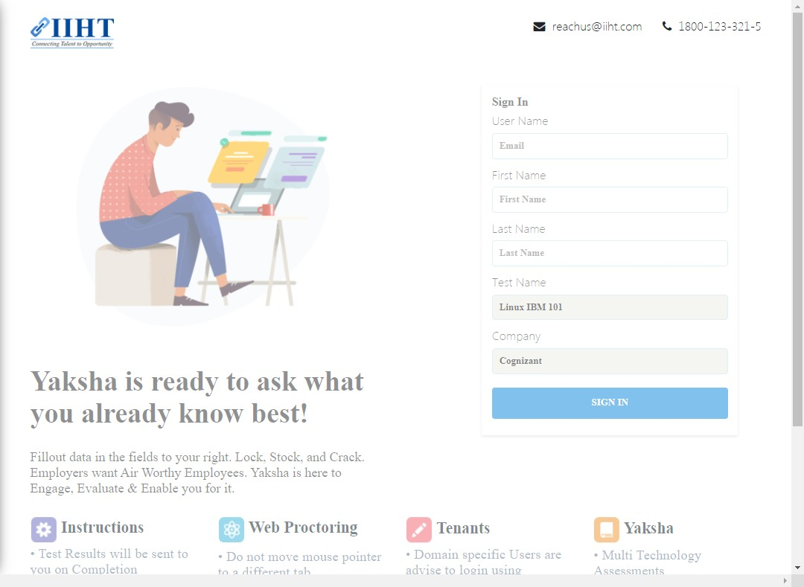

# Notes:

Yaksha Logo across all test links

# Recommendation:

Yaksha Logo, decided to be the one as a homogenous representation within the Test Journey

# Heuristic: Help and documentation

# Severity: 4

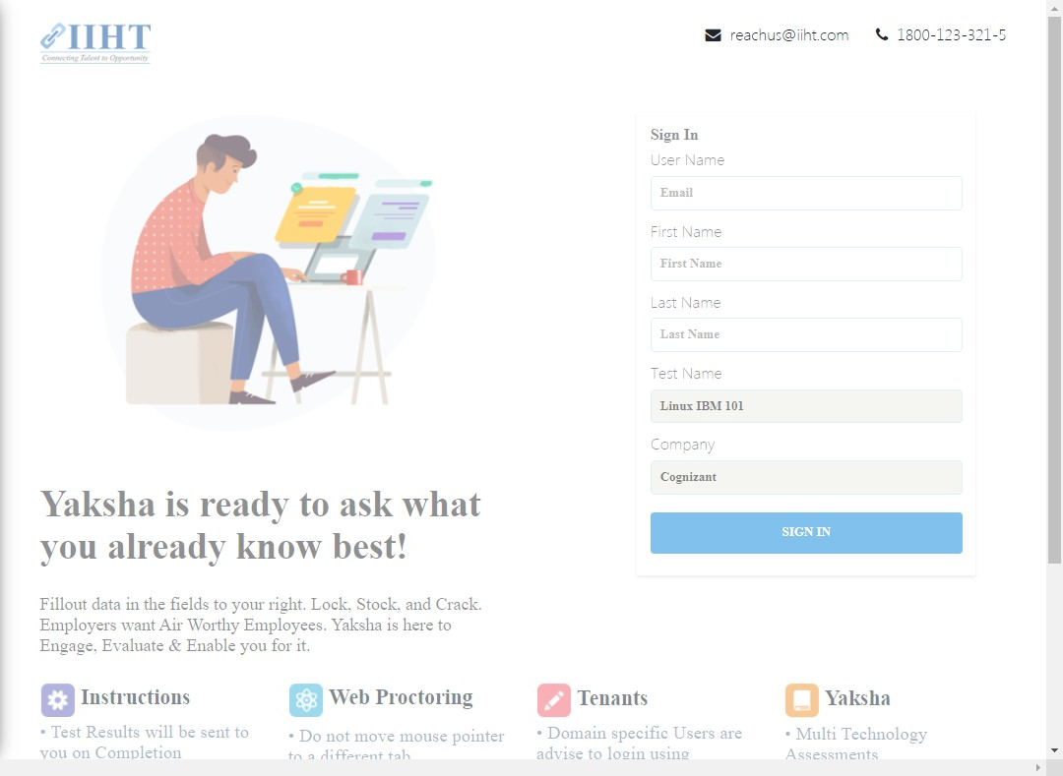

# Notes:

This must be the test configurator

# Recommendation:

This is the support email address that is applicable for resolution through Unified Help Desk and Yaksha Operations Team

# Heuristic: Help and documentation

# Severity: 1



# Notes:

The number is not necessary

# Heuristic: User control and freedom

# Severity: 4

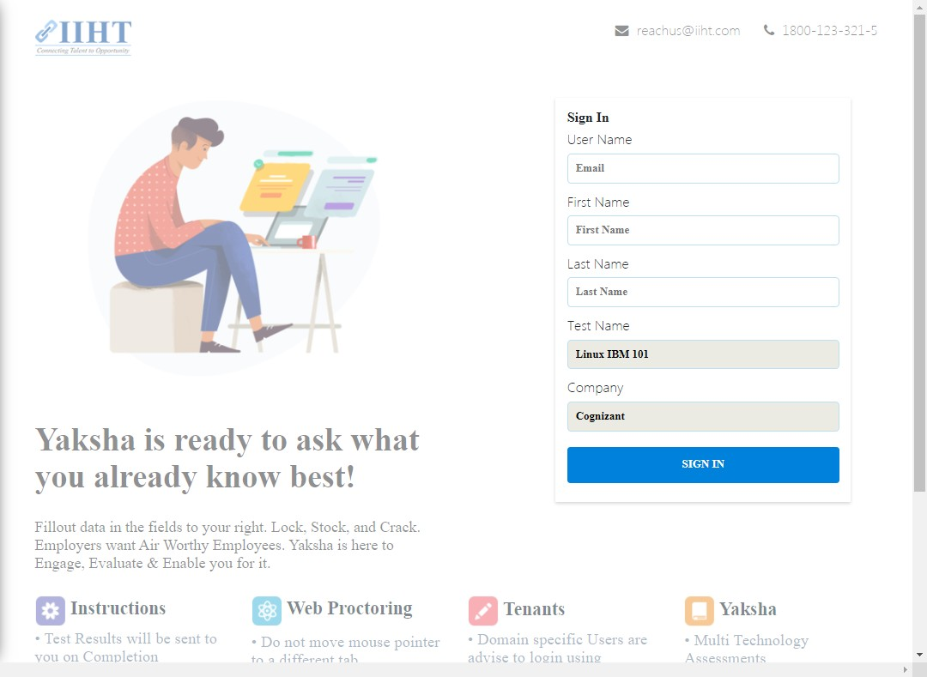

# Notes:

Let the login page remind the user about simplicity of details being asked

# Recommendation:

Check the Login details of Codeacademy.com or any other websites to provide center of the page or top of the mind recall of data capture. the color should be sleek than simple behind this entry level

# Heuristic: Aesthetic and minimalist design

# Severity: 4

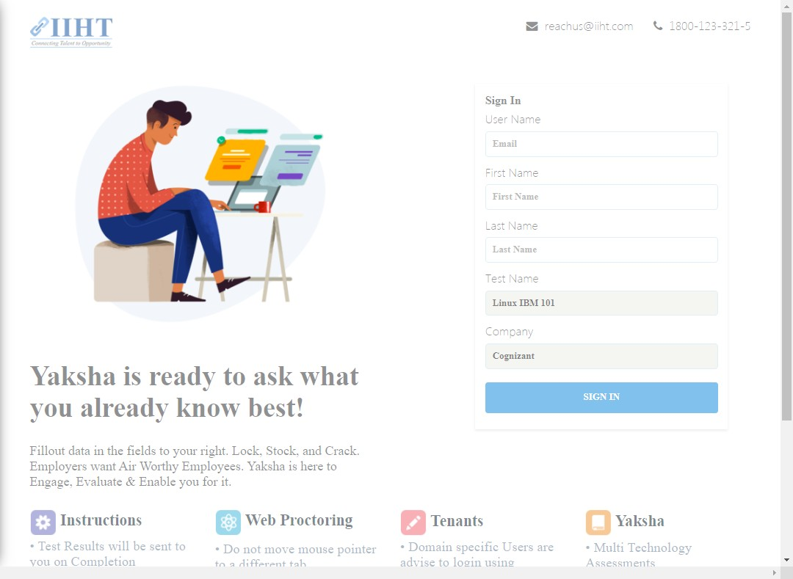

# Notes:

This is not required

# Recommendation:

To be removed and the sign in details to be moved to the center of the page

# Heuristic: Visibility of system status

# Severity: 4

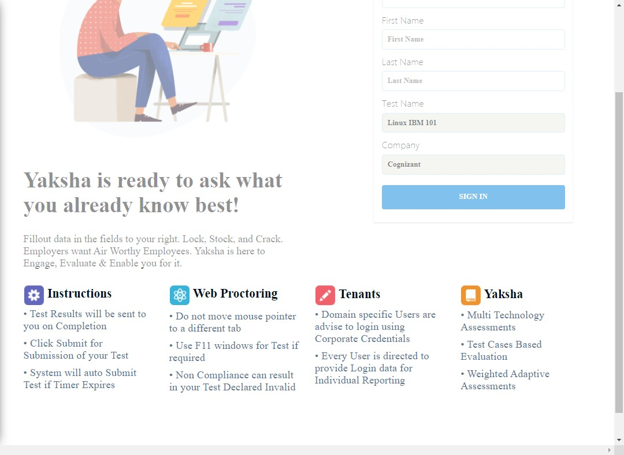

# Notes:

The entire process of test beginning should begin after click "SIGN IN" page.

# Recommendation:

all of these must be represented in a standard document format for "click to start the test" inside which all the test information should be present including duration, test name, number of questions and test administrator